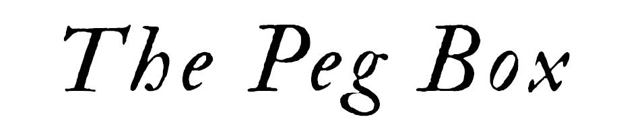

Price List – January 2021
These prices to be used as a guide only

Bridges
Prices include fitting

Violin Premium (A Grade) ~ £117

Violin Standard (B Grade) ~ £112

Viola Premium (A Grade) ~£125

Viola Standard (B Grade) ~ £120

Cello Premium (French, A Grade) ~ £175

Cello Student (French, C Grade) ~ £145

Double Bass Premium (A Grade) ~ £195

Double Bass Student (C Grade) ~ £165

Belgian bridges for cello or bass also available ~ please contact us to discuss your requirements

Soundposts

Violin/Viola ~ £35

Cello ~ £40

Sound adjustment service also available

Saddles and Nuts

Violin/Viola Saddle ~ £25

Violin/Viola Nut ~ £30

Cello Nut ~£35

Misc.

String fitting service ~ £11

Fingerboard Shooting ~ £50

Peg fitting ~ TBC

General service ~ instrument clean, peg paste, bridge and soundpost check ~ £22

Crack repairs ~ please enquire.

Strings
Includes optional fitting if required
Below is a small selection of what we can order ~ if you want something that is not listed let us know! Individual strings also available.

Pirastro Tonica Violin Set ~£28

Thomastik Dominant Violin Set ~ £48 (price provisional – looking for new supplier)

Evah Pirazzi Violin Set (Gold E) ~ £95

Evah Pirazzi Gold Violin Set ~ £140

Jargar Cello Set ~£110

Larsen Cello Set ~ £181

Accessories including rosins, shoulder rests, end pin holders, cases etc. are also available.

Instruments

We have a variety of instruments for all abilities either in stock or available to order, set up by us here in Jersey. We also undertake commissions! Please contact us to discuss your requirements.

www.thepegbox.co.uk
www.jerseyacademyofmusic.co.uk/the-peg-box/
david@thepegbox.co.uk
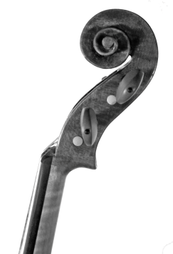
davids_violins

